Walk 5: The Big Houses of Tilstone Fearnall 6Km

This walk takes you around the backs of the three large houses built in Tilstone Fearnall in the 19th Century: Tilstone Lodge, Tilstone Hall and Tilstone House.

Tilstone Lodge is the most extensive combining a working farm and an elegant residence complete with entrance lodges at the ends of its two long approach drives. Tilstone Hall remains a working farm, whilst Tilstone House has seen major changes in recent years including separating off the stables area for a housing development.
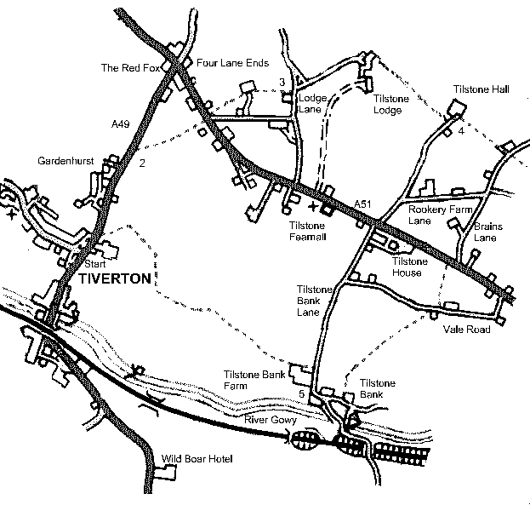

Start From the starting point, walk uphill along the A49 for about 0.5 km past the entrance to the Deeside Ramblers Hockey Club and Gardenhurst Estate.

2 At the lay-by there is a wooden stile into a field. Notice the remains of a sandstone stile. These were once very common in this part of Cheshire and there is a better example further on. The path heads diagonally to the 2 big trees in the far corner of the field where a stile leads into the next field through a thick holly hedge. Over this stile, the path continues N with the field boundary hedge on your right, aiming for a stile next to the field gate.
Cross the busy A51 and immediately opposite there is a stile that gives onto a small field where the path follows the boundary on your left to another stile. Cross into a much larger field, aiming just to the right of the bungalow. There is a stile in the hedge, which gives onto the drive leading into the bungalow. Cross the drive and continue NE with the hedge screening the bungalow on your left and then past an isolated oak tree in the middle of the field. You are aiming for another stile beneath a large oak and holly bush. You will cross on the wooden stile, do not use the gate alongside the stile, despite seeming an easier way; it will put you into the wrong field. Notice a much better example of a Cheshire sandstone stile alongside the new wooden stile. The cross pieces would have been wooden, shaped to wedge into the recesses carved into the stile verticals. There is a functional example of this type of stile on Walk 4.
You are aiming for a stile and narrow track just beyond the high voltage pole. Take this track between a hedge and the walls of Dairy Farm to emerge onto Lodge Lane.

3 Turn left along Lodge Lane for 50m to the back drive and lodge leading up to Tilstone Lodge. Ignore the stile and footpath sign just to the left of the drive and don’t be put off by the PRIVATE sign 20m up the drive. The drive is a right of way on foot and you will spot a reassuring footpath sign just in front of the cattle grid.
Follow the drive for 300m until it appears to go into a melee of farm buildings. The way is a little tricky here but the aim is to skirt around the buildings on the north side and pick up a good track beyond; there are good way marks at each junction.
Tilstone Lodge house can be glimpsed through the hedges on your right, but there has been much work in recent years to improve the owners’ privacy and views of the house are now much reduced. There is a gate at the end of the track with a stile alongside. Continue in to the next field, usually given over to grazing ponies. You are heading E for Tilstone Hall and at the far corner of this field is a gate giving onto a small patch of woodland. The path continues alongside the fence to another gate onto the approach drive for Tilstone Hall. Turn left onto the drive and follow it to the right of the Hall buildings (ignore a turning to the left in front of the Hall).

4 Keeping the stone wall topped by a hedge on your right, start to walk away from the Hall across an open space in front of a silage heap. The path continues over a wooden fence (stile missing) into a field. From this slightly elevated position, looking west there are views of the Pennines and Derbyshire and Jodrell Bank radio telescope, and to the north the spire of Over church. Head E across the field to the band of trees opposite, just to the right of a house. You will find a stile by a field gate that leads over a small stream, crossed by a wooden sleeper bridge. Keep close to the fence line of what is now a private garden, recently recovered from a tangled birch copse, heading for a stile and gate onto Brains Lane.

Over the stile, turn right down Brains Lane for 600m to the A51. Ignore the apparent sweep of the road right into Rookery Farm Lane, continuing straight ahead at this junction. Cross over the busy A51 and turn right onto the footway for 40m where there is a stile in the hedge by a young ash tree. Cross into the field heading S and walk alongside a fence on your left towards another stile. The ground now begins to fall away to the Gowy valley and the tower of Bunbury church, 2km away, comes into view. Over 1 more stile and the path swings left into the corner of the field and another stile by a gate onto Vale Road.

Turn right and follow Vale Road for 50m to a footpath sign on your left marked ‘Canal’.
Continuing along Vale Road would bring you behind the 3rd big house of Tilstone Fearnall, Tilstone House and eventually (400m) to Tilstone Bank Lane where a left turn will take you to Tilstone Bank Farm avoiding the potentially tricky footpath to the same part of Tilstone Bank.

The track runs downhill but don’t miss the stile on your right after 20m that leads into a large field usually planted with maize. Follow the hedge line on your left for 50m and then you must strike out SW across the field. Getting across this field can be a challenge as the horizon is almost featureless at this point though two treetops can just be seen on the horizon. Head for a point between them. You are aiming for a stile in front of an isolated house; it has a 3m pole alongside it, which serves as a landmark from across this large open field, though it can be difficult to spot against the trees beyond. A nearby high voltage pole, just left of the line of the path, is probably a better landmark. Cross the farm track to a stile opposite, across a narrow section of open field and then follow the hedge on your left for 30m to a stile. Cross into a small field, now keeping the hedge on your right to find a stile into a small paddock. Across the paddock, an obvious gate gives onto a short track that joins the main track at a footpath. Turn right for Tilstone Bank Lane.

5 At Tilstone Bank Lane, turn right. Just past the buildings of Tilstone Bank Farm, there is a stile on your left into the farmyard, which takes you around a large silage heap; ignore the more inviting concrete track at this point. Keeping close to the perimeter fencing of the silage heap will bring you to a stile onto a concrete track, turn right over this stile and follow the track for 1/4km to a stile on your left into an open field. Follow the line of the fence on your right for 300m over a rise, leaving the fence line just short of the corner of the field before the oak trees. Head downhill across the field for the stile 150m away to your right, just beyond a group of 5 small trees. The high point of this field provides some lovely views of the Peckforton Ridge with its castles, and on the distant horizon the Clywdian Hills with the characteristic outline of Moel Famau.

Over the stile, follow the boundary wire fence on your left and in the corner of the field turn sharp right to follow the hedge to a metal gate. Go through this gate and head off across the open field, initially aiming to the left of the electricity pole on the far side. As you move across this field, you will soon be able to spot the stile in the corner. This stile leads onto a rough farm track with another wooden stile opposite. Use this to cross into the last field before the A49 Whitchurch Road, which you will probably be able to hear. Follow the hedge line on your right to the final wooden stile and down some concrete steps onto the footway. Turn left downhill to arrive at the starting point of Smithy Green in 100m.

